**Name:- zeyad Mohamed dawood section:- (3)**

**Q1: Calculate the time for each process, define the priority?**

**Answer :**

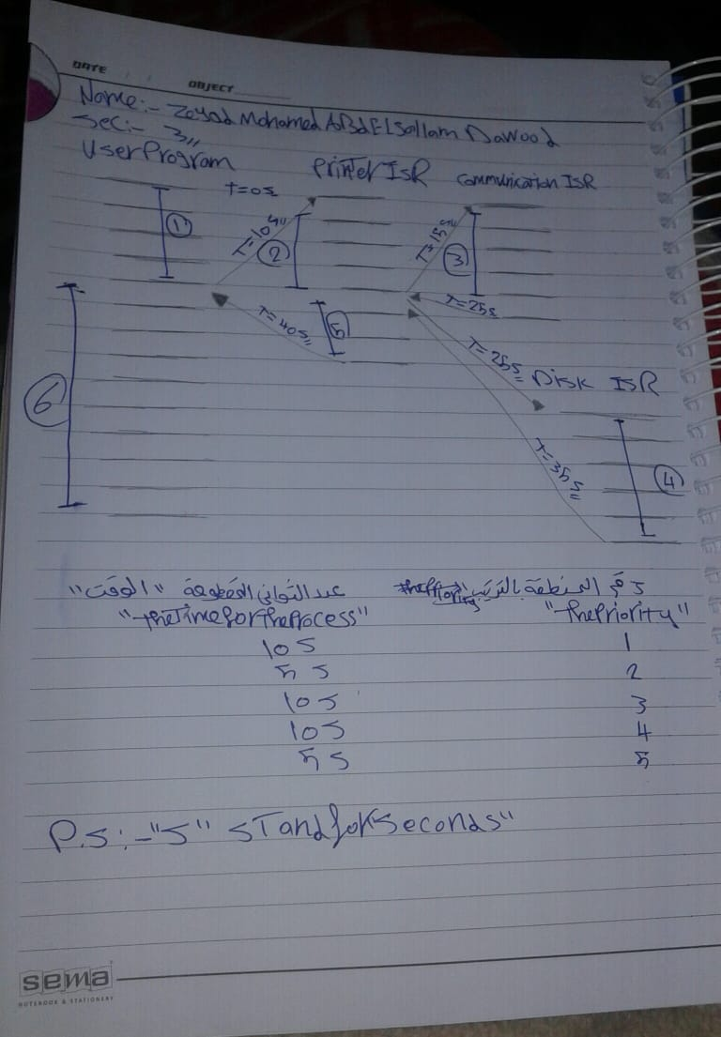

A :-

The priority :- the time :-

1. User program 10 s
2. Printer ISR 5 s
3. Communication ISR 10 s
4. Disk ISR 10 s
5. Printer ISR 5 s